If you are interested in taking course(s) at another institution for transfer credit consideration, please follow the steps outlined below.
If your request is approved, you will need to submit an official transcript to Info@Trocaire.edu that documents a minimum grade of “C” was earned for each class included in your request in order to receive transfer credit.
Please note, course registration will be delayed if course(s) taken at another institution are pre-requisite courses for upcoming registration. Registration will be blocked until you provide the official transcript, the transfer credit analysis has been completed, and the transfer credits are awarded.
If your request is denied, you will be notified via your Trocaire email with the justification for the decision and/or request for additional information.
STEP 1
- Identify the institution name & course number where you want to take the course and process the request following the STEPs below.
Not sure what course(s) will transfer?
- Search by institution using the Transfer Credit Guide located on the Registrar page of the college website.
- Simply click on the name of the institution, then click on the course name to determine how the course will apply for transfer credit.
Here’s a sample from ECC.
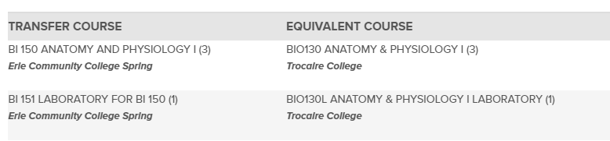
Still can’t find the course you want to try to transfer?
- Send your request to RegistrarTeam@Trocaire.edu

STEP 2
- After you have the name of the institution & course number(s), log into the Student Portal.

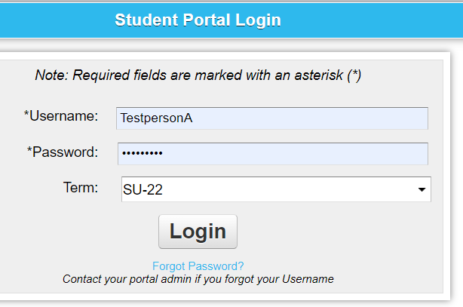

STEP 3
- Click on Transfer Credits from Another institution
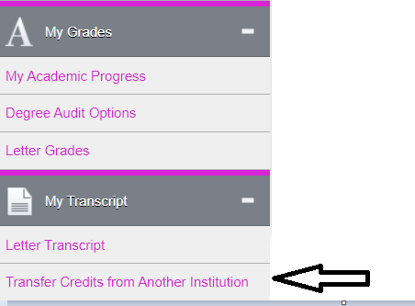
STEP 4
- Click on START A REQUEST
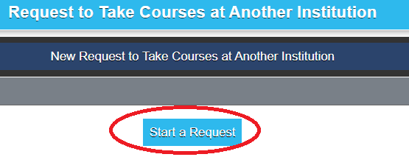

STEP 5
- Enter: COLLEGE, & SEMESTER then click on aDD a COURSE
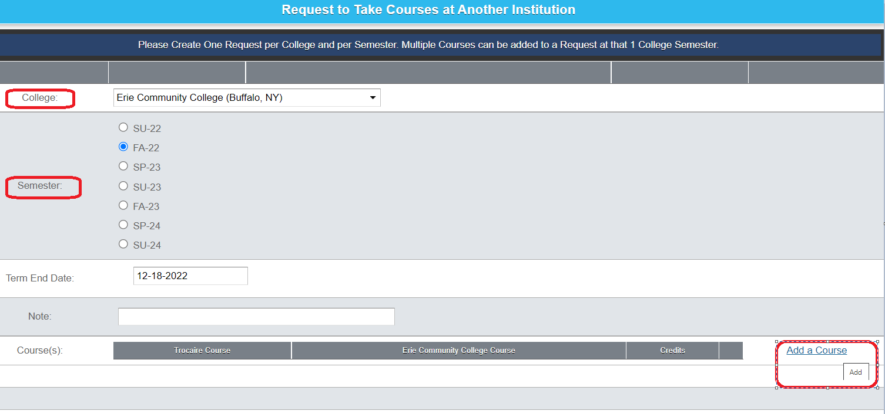
STEP 6
- Select SEARCH
- Enter: department & Course Type (collected in STEP 1)
- If you don’t have this information, click on SEARCH to find class that you want to apply for transfer credit.
- When requesting classes that require a lab, be sure to request for BOTH the class and the lab.
- When requesting classes from more than one institution, separate requests will be required. Only one institution per request.

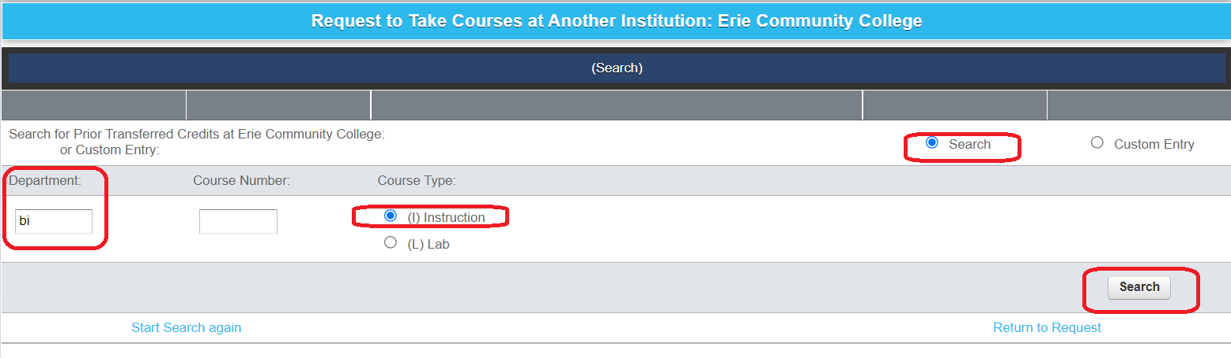

Click the COURSE button then click SAVE

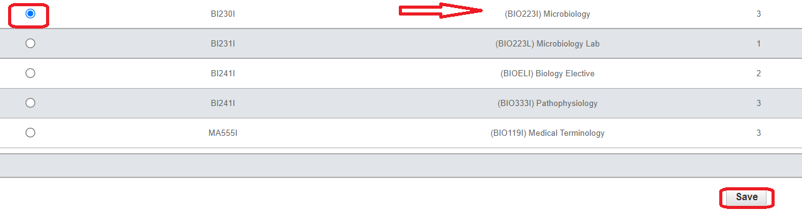
SELECT THE NEXT CLASS (Class & Lab need to be entered individually)
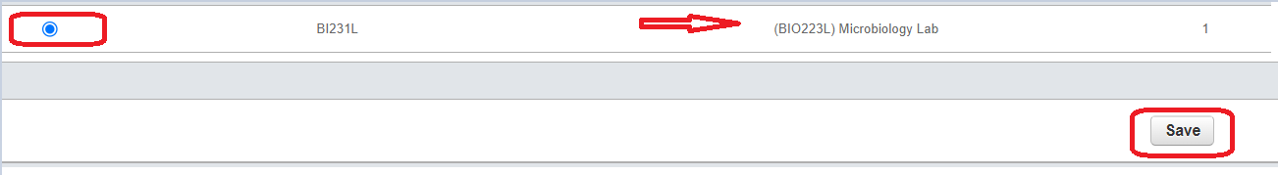
REVIEW & SUBMIT (See the FINISHED EDITING LINE)
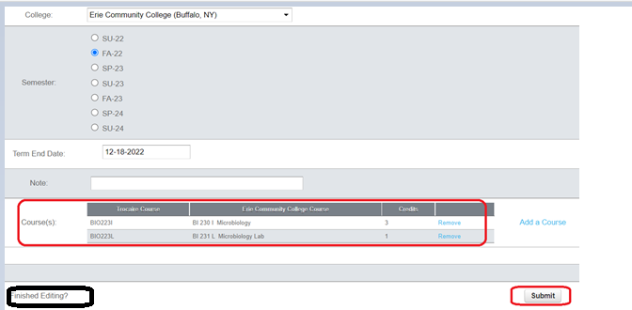

Students will receive a response via their Trocaire email within one to two business days that includes the outcome of the request (accept or reject) and further instruction.
If you have any questions please contact RegistrarTeam@Trocaire.edu.

