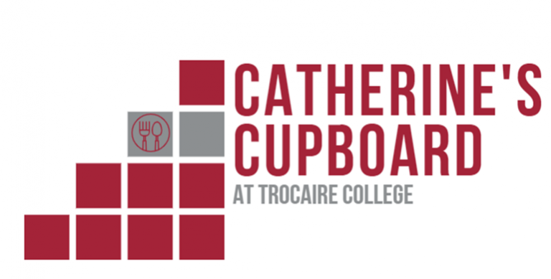
Available food items in Catherine’s Cupboard
fall 2020
BEANS
baked
black
pork and beans
garbanzo
RAMEN NOODLES
chicken
beef
CANNED VEGETABLES
peas
carrots
corn
canned potatoes
mixed vegetables
BREAKFAST
cold cereal
breakfast bars
Pop Tarts
GRAINS
pasta/macaroni
macaroni & cheese
rice
tomato sauce and marinara sauce
canned tuna and canned chicken
Chef Boyardee
ravioli
crackers
peanut butter
jam

SOUP
tomato
cream of mushroom
vegetable
beef
minestrone
chicken noodle
BEVERAGES
tea, plain and green
coffee
FRUIT
peaches
pears
fruited Jell-O and plain Jell-O
applesauce
pudding, chocolate and vanilla
HYGIENE PRODUCTS
deodorant
soap
shampoo
toothpaste
toothbrush
laundry detergent

