 

http://buffalomedicalgroup.com/wp-content/themes/BMG/images/logo.jpg 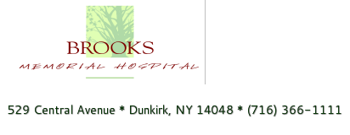

Kaleida Health 

 

 

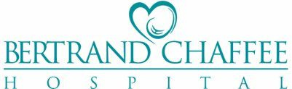 PSA Healthcare

DENT Neurologic Institute 

 People, Inc.

Kalos Health Heathwood Assisted Living at Williamsville